1. ***Consider the LIBRARY relational database schema shown in Figure shown below, which is used to keep track of books, borrowers, and book loans. Referential integrity constraints are shown as directed arcs in figure. Write down relational expressions for the following queries:***

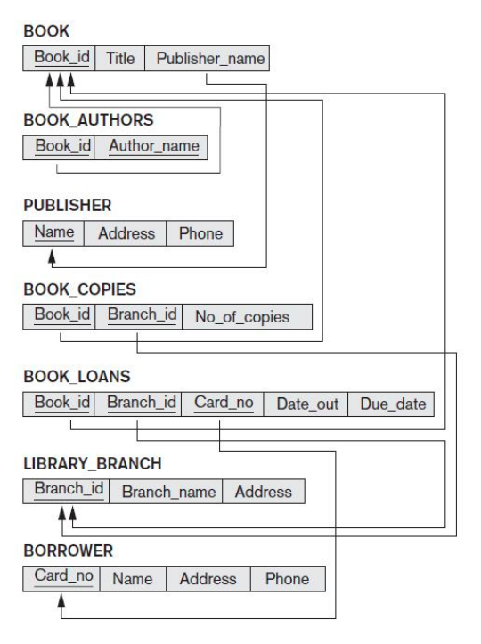

* 1. ***Retrieve the number of copies of the book titled “The Lost Tribe” are owned by the library branch whose name is ‘Sharpstown’?***
  2. ***Retrieve the number of copies of the book titled The Lost Tribe are owned by each library branch?***
  3. ***Retrieve the names of all borrowers who do not have any books checked out.***
  4. ***For each library branch, retrieve the branch name and the total number of books loaned out from that branch.***

1. ***Consider the two tables T1 and T2 shown in Figure below. Show the results of the following operations:***

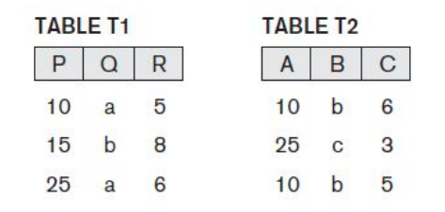

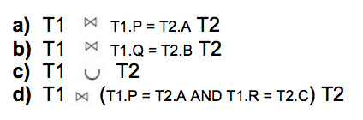

|  |  |  |  |  |  |
| --- | --- | --- | --- | --- | --- |
| **P** | **Q** | **R** | **A** | **B** | **C** |
| 10 | a | 5 | 10 | b | 6 |
| 25 | a | 6 | 25 | c | 3 |
| 10 | a | 5 | 10 | b | 5 |

|  |  |  |  |  |  |
| --- | --- | --- | --- | --- | --- |
| **P** | **Q** | **R** | **A** | **B** | **C** |
| 15 | b | 8 | 10 | b | 6 |
| 15 | b | 8 | 10 | b | 5 |

|  |  |  |
| --- | --- | --- |
| **P** | **Q** | **R** |
| 10 | a | 5 |
| 15 | b | 8 |
| 25 | a | 6 |
| 10 | b | 6 |
| 25 | c | 3 |
| 10 | b | 5 |

|  |  |  |  |  |  |
| --- | --- | --- | --- | --- | --- |
| **P** | **Q** | **R** | **A** | **B** | **C** |
| 10 | a | 5 | 10 | b | 5 |

1. ***Specify the following queries on the COMPANY relational database state shown in Figure below (next page) using the concept of nested queries and the relational operators.***

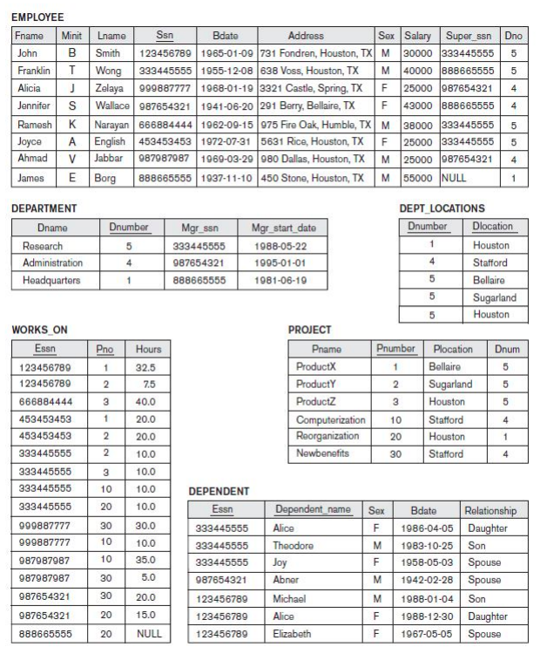

* 1. ***Find the names of all employees who are directly supervised by ‘Franklin Wong’.***

[SELECT](http://localhost:8888/phpMyAdmin/url.php?url=https://dev.mysql.com/doc/refman/5.5/en/select.html) concat(E.fname, " ", E.lname) AS Names

FROM employee AS E, employee as M

WHERE E.super_ssn = M.ssn

[AND](http://localhost:8888/phpMyAdmin/url.php?url=https://dev.mysql.com/doc/refman/5.5/en/logical-operators.html#operator_and) M.fname = 'Franklin'

[AND](http://localhost:8888/phpMyAdmin/url.php?url=https://dev.mysql.com/doc/refman/5.5/en/logical-operators.html#operator_and) M.lname = 'Wong'

* 1. ***Retrieve the names of all employees who do not work on any project.***

[SELECT](http://localhost:8888/phpMyAdmin/url.php?url=https://dev.mysql.com/doc/refman/5.5/en/select.html) concat(fname, " ", lname) AS Names

FROM employee

WHERE ssn [NOT](http://localhost:8888/phpMyAdmin/url.php?url=https://dev.mysql.com/doc/refman/5.5/en/logical-operators.html#operator_not) [IN](http://localhost:8888/phpMyAdmin/url.php?url=https://dev.mysql.com/doc/refman/5.5/en/comparison-operators.html#function_in) ([SELECT](http://localhost:8888/phpMyAdmin/url.php?url=https://dev.mysql.com/doc/refman/5.5/en/select.html) DISTINCT(w_ssn) FROM `works_on`)

* 1. ***For each department, retrieve the department name and the average salary of all employees working in that department.***

[SELECT](http://localhost:8888/phpMyAdmin/url.php?url=https://dev.mysql.com/doc/refman/5.5/en/select.html) D.dname, [AVG](http://localhost:8888/phpMyAdmin/url.php?url=https://dev.mysql.com/doc/refman/5.5/en/group-by-functions.html#function_avg)(E.salary) AS "AVG_SALARY"

FROM employee AS E, department AS D

WHERE E.dno = D.dnumber

GROUP BY D.dnumber

* 1. ***List the names of all employees who work in the department that has the employee with the highest salary among all employees.***

[SELECT](http://localhost:8888/phpMyAdmin/url.php?url=https://dev.mysql.com/doc/refman/5.5/en/select.html) concat(fname, " ", lname) AS Names

FROM employee

WHERE dno [IN](http://localhost:8888/phpMyAdmin/url.php?url=https://dev.mysql.com/doc/refman/5.5/en/comparison-operators.html#function_in) (

[SELECT](http://localhost:8888/phpMyAdmin/url.php?url=https://dev.mysql.com/doc/refman/5.5/en/select.html) dno

FROM employee

WHERE salary = ([SELECT](http://localhost:8888/phpMyAdmin/url.php?url=https://dev.mysql.com/doc/refman/5.5/en/select.html) [MAX](http://localhost:8888/phpMyAdmin/url.php?url=https://dev.mysql.com/doc/refman/5.5/en/group-by-functions.html#function_max)(salary) FROM employee))

* 1. ***List the names of all employees whose supervisor’s supervisor has '888665555' for SSN.***

[SELECT](http://localhost:8888/phpMyAdmin/url.php?url=https://dev.mysql.com/doc/refman/5.5/en/select.html) concat(fname, " ", lname) AS Names

FROM employee

WHERE super_ssn [IN](http://localhost:8888/phpMyAdmin/url.php?url=https://dev.mysql.com/doc/refman/5.5/en/comparison-operators.html#function_in) (

[SELECT](http://localhost:8888/phpMyAdmin/url.php?url=https://dev.mysql.com/doc/refman/5.5/en/select.html) ssn

FROM employee

WHERE super_ssn = '888665555')

1. ***Consider the following set of requirements for a UNIVERSITY database that is used to keep track of student’s transcripts.***
   1. ***The university keeps track of each student’s name, student number, Social Security number, current address and phone number, permanent address and phone number, birth date, sex, class (freshman, sophomore, ..., graduate), major department, minor department (if any), and degree program (B.A., B.S., ..., Ph.D.). Some user applications need to refer to the city, state, and ZIP Code of the student’s permanent address and to the student’s last name. Both Social Security number and student number have unique values for each student.***
   2. ***Each department is described by a name, department code, office number, office phone number, and college. Both name and code have unique values for each department.***
   3. ***Each course has a course name, description, course number, number of semester hours, level, and offering department. The value of the course number is unique for each course.***
   4. ***Each section has an instructor, semester, year, course, and section number. The section number distinguishes sections of the same course that are taught during the same semester/year; its values are 1, 2, 3, ..., up to the number of sections taught during each semester.***
   5. ***A grade report has a student, section, letter grade, and numeric grade (0,1, 2, 3, or 4)***

***Design an ER schema for this application, and draw an ER diagram for the schema. Specify key attributes of each entity type, and structural constraints on each relationship type. Note any unspecified requirements, and make appropriate assumptions to make the specification complete.***

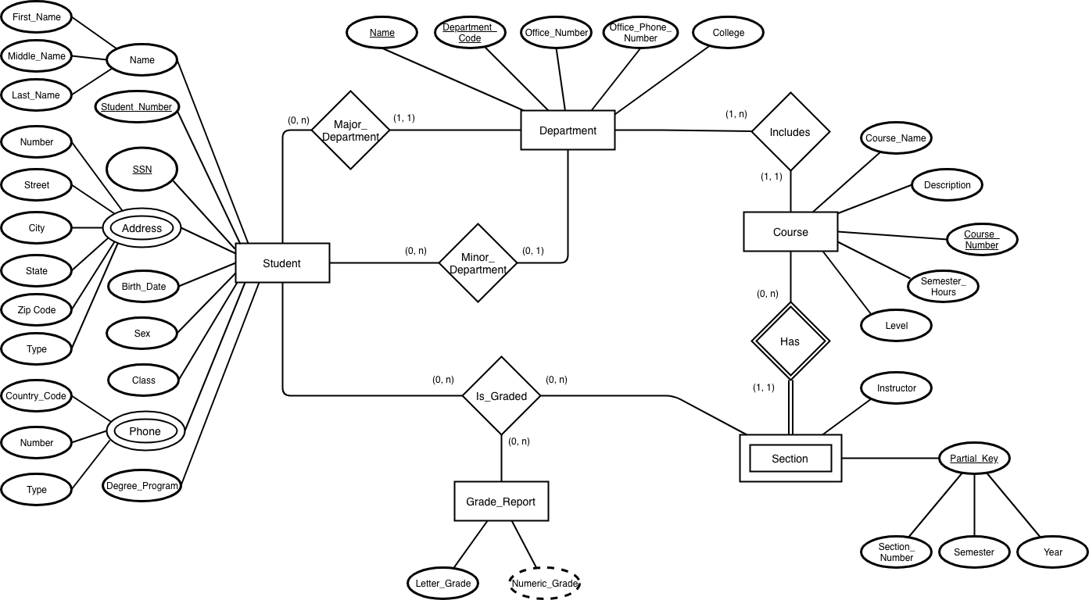

Type under both Phone attribute and Address of Student relation is an Enum valued attribute which consists of Permanent and Current Values.

1. ***Consider the ER diagram shown in the figure below for part of a BANK database. Each bank can have multiple branches, and each branch can have multiple accounts and loans***

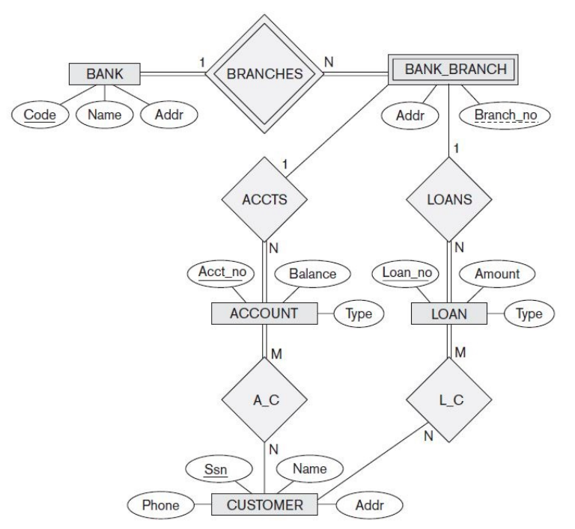

* 1. ***List the strong (non-weak) entity types in the ER diagram.***

Strong Entity Types = { BANK, ACCOUNT, LOAN, CUSTOMER }

* 1. ***Is there a weak entity type? If so, give its name, partial key, and identifying relationship.***

Weak Entity Type: BANK_BRANCH

Partial Key: Branch_No

Identifying Relationship: BRANCHES

* 1. ***What constraints do the partial key and the identifying relationship of the weak entity type specify in this diagram?***

The partial key BranchNo in BANK-BRANCH specifies that the same BranchNo value may occur under different BANKs. The identifying relationship BRANCHES specifies that BranchNo values are uniquely assigned for those BANK-BRANCH entities that are related to the same BANK entity. Hence, the combination of BANK Code and BranchNo together constitute a full identifier for a BANK-BRANCH

* 1. ***List the names of all relationship types, and specify the (min, max) constraint on each participation of an entity type in a relationship type. Justify your choices.***



Every Bank has at least one or more bank branches. And every bank branch is associated to a bank.

A bank branch can have 0 or more loans sanctioned. While, a loan is associated to a single bank branch. Similarly a bank branch can have 0 or more accounts. But every account is mapped or associated to a bank branch.

Every loan or an account has a single or multiple customers under it. But not all customers can have only loans or only accounts associated to a bank branch.

1. ***Cardinality ratios often dictate the detailed design of a database. The cardinality ratio depends on the real-world meaning of the entity types involved and is defined by the specific application. For the following binary relationships, suggest cardinality ratios based on the common-sense meaning of the entity types. Clearly state any assumptions you make.***



|  |  |  |
| --- | --- | --- |
| **Entity 1** | **Cardinality Ratio** | **Entity 2** |
| STUDENT | 1 - Many  Here, every student is assigned with an unique social security number. But a student can have ‘N’ number of copies of the same. Every SSN is unique to the student. | SOCIAL _SECURITY _CARD |
| STUDENT | Many - Many  Every student can have multiple teachers based on the courses he takes up. Every teacher would have multiple students to teach to. | TEACHER |
| CLASSROOM | Many – Many  Every classroom is bound by walls on all the sides. A circular classroom would have infinite walls, considered when walls are supposed to be straight.  Every wall can be shared between classrooms. | WALL |
| COUNTRY | 1 – 1  Every country is governed by one president considering a normal state in the country. Every current president should be a president of the country. Excluding the presidents of organizations, clubs, groups, etc. | CURRENT _PRESIDENT |
| COURSE | Many – Many  Every course can have multiple text books written for it. Usually textbooks can have multiple editions too. Every textbook could be a reference for multiple courses too. | TEXTBOOK |
| STUDENT | Many – Many  A Student can be a part of multiple class. While a class has multiple students as a part of it. | CLASS |
| CLASS | Many – 1  Assuming a class has only one instructor. If a class allowed multiple teachers, then the mapping would be Many – Many.  Every instructor can have multiple class to take. | INSTRUCTOR |

References:

* <http://comp.eng.ankara.edu.tr/files/2013/03/ErDiagram.pdf>
* Fundamentals of Database Systems, Sixth Edition, by Elmasri/Navathe
* <http://www.tutorialspoint.com/dbms/er_model_basic_concepts.htm>